Teachers As Readers

Have you read a good book lately? Do you wish you had a friend to discuss it? Teachers As Readers is the perfect venue!

Every council should have or create a Teachers As Readers group??

Teachers as Readers (TAR) is a wonderful way to:

- Build professional relationships
- Meet new friends
- Stay informed of the latest in literacy instruction/ research
- Keep abreast of new books and literature
- Expand your horizons with new genres and book choices
- Read and have fun with colleagues in an informal environment
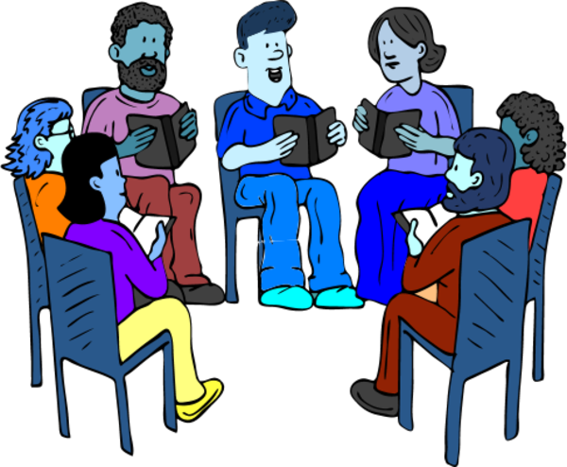
How do I get my council involved?
- Contact me: Donna Redmond,
Teachers As Readers State Chairperson
donna.redm2@gmail.com
410-360-2089 (h) 410-440-4273 (c )

- Send me:
  - The name of your Teachers As Readers Chairperson, email address, phone number, and home address.
  - Keep me informed of your Teachers As Readers meetings and activities scheduled by your group. Just place my name on your contact list.

Your council’s Teachers As Readers group has the flexibility of choosing books to read - professional, nonfiction, fiction, or children’s literature, as well as when and how often you meet.

Don’t hesitate to email me with any questions.
Read! Read! Read! Happy Reading!

Donna

