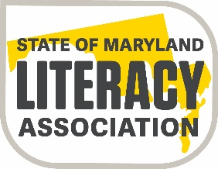

State of Maryland Literacy Association
Joseph J. Fox, Jr. Memorial Scholarship
The Joseph J. Fox, Jr. Memorial Scholarship will be awarded to a graduate of any Maryland high school who plans to major in education at an accredited college or university. The recipient of this scholarship must meet the specific criteria for the scholarship.
The scholarship is awarded for $2,000.00. The selected recipient will receive the scholarship funding upon presentation of a copy of a college or university tuition bill.
Scholarship Criteria
- Applicant must verify graduation from a Maryland high school.
- Applicant must be accepted and enrolled as a full-time undergraduate student at an accredited college or university.
- Applicant must major in Education with the intent to pursue teaching as a career.
- Applicant must have maintained an overall GPA of 3.2 or better in high school and submit a high school transcript with the application.
- Applicant must document current or previous community service in education-related activities or organizations/clubs, etc.
- Applicant must submit a completed application that follows the scholarship rubric
- Applicant must apply by the scholarship deadline.
All applications must be submitted to the SoMLA Scholarship Committee Chairperson and be postmarked by April 15, 2022.
Ronnie Cantor
Scholarship Committee Chairperson
61 Fox Run Way
Arnold, Maryland 21012

Applicants can go to the SoMLA website www.somla.online on June 1, 2021 to see if they have been selected as a scholarship winner. The winner will also receive a letter informing them of their selection for this scholarship.

