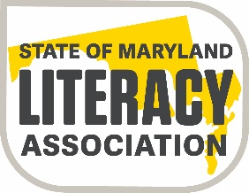

State of Maryland Literacy Association
Joseph J. Fox, Jr. Member Memorial Scholarship/Grant
The Joseph J. Fox, Jr. Member Memorial Scholarship/Grant will be awarded to members in good standing in a local reading chapter. Recipients of this scholarship/grant must meet the specific criteria for the scholarship/grant and be promoting literacy in the state of Maryland.
Each scholarship/grant is awarded for up to $1,000.00. Selected recipients will receive the scholarship/grant funding at a SoMLA state chapter meeting.
Scholarship/Grant Criteria
- Applicant must be a member in good standing of SoMLA.
- Applicant must be accepted and enrolled as a graduate or post-graduate student at an accredited college or university or involved in a project that promotes literacy.
- Applicant must major in reading or a reading-related field, such as English, or be participating in a literacy endeavor that benefits reading education.
- If furthering their own education, the applicant must maintain an overall GPA of 3.0 or better as a graduate or post-graduate student.
- Applicant must document current or previous participation in state or local reading council activities, as well as, being a part of community service in reading related activities.
- Applicant must submit a completed application that follows the scholarship/grant rubric
- Applicant must apply by the scholarship deadline.

All applications must be submitted to the SoMLA Scholarship/Grant Committee Chairperson and be postmarked by June 1, 2021.
Don Bailey
Scholarship Committee Chairperson
1509 Augusta Way
Crofton, Maryland 21114

Winning applicants will be notified by mail.

