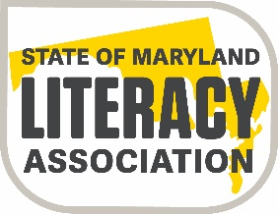

State of Maryland Literacy Association
Member Joseph J. Fox, Jr. Memorial Scholarship/Grant Application Form
2020-2021

Applicant: Please complete in full. Please type or print carefully.

Name: ________________________________________________________________
(last) (first) (middle)

Address: ___________________________________
___________________________________
Phone Number: ______________________________

Email Address: _______________________________

Name of Local Reading Chapter: __________________________________________________

If applying for a scholarship, what college or university are you attending: ____________________________________________________________________________

If applying for a grant, what project/research activity are you planning: ____________________________________________________________________________

List the names of two people, other than relatives, whom you have asked to submit a letter of recommendation to the scholarship committee:

Name: __________________________________ Relationship: _________________________

Name: __________________________________ Relationship: _________________________

Please submit an essay explaining the reasons you are qualified and should receive this scholarship or an essay explaining the project/research activity that you would be using this grant for. Refer to the three-point rubric for guidance.

