ORTHOGRAPHIC MAPPING: DEVELOPING WORD RECOGNITION

OBJECTIVES
We can:
- Explain the connection between orthographic mapping and the brain’s function.
- Identify components necessary for orthographic mapping.
- Facilitate orthographic mapping activities for phonic patterns.
- Facilitate orthographic mapping activities for irregular high frequency words.

ANTICIPATION CHART

Before |  | Statement | After
True | False |  | True | False
 |  | Because reading is simple and the ability to decode is innate, explicit instruction does not have a great effect on one’s ability to read.
 |  | Orthographic mapping is influenced by a teacher’s actions.
 |  | There are specific activities that support the pathways between meaning, pronunciation, and spelling.

THE BRAIN AND READING

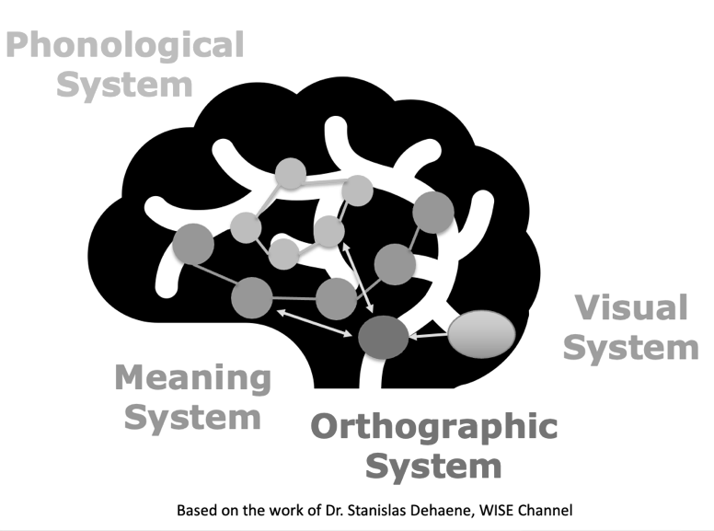

The pathways (or mapping) must be taught.
Humans are born with a phonological, meaning, and shape recognition system.
When letters are learned, the shape recognition system, becomes our letter box.

“…to read an individual word, a child needs to create an orthographic map by linking the word’s orthographic information (spelling) to its phonology (pronunciation) and semantic information (meaning.)”
~Dr. Julia B. Lindsey

CONNECTING ORTHOGRAPHY TO PHONOLOGY

Sample Dialogue
T: What is the first sound you hear in lad?
S: /l/
T: What letter makes that sound?
S: L
T: What is the next sound you hear in lad?
S: /ǎ/
T: What letter makes that sound?
S: A
T: What is the last sound you hear in lad?
S: /d/
T: What letter makes that sound?
S: D

l
d
a

CONNECTING SPELLING, PRONUNCIATION, AND MEANING

“…spellings activated grapheme–phoneme connections to better secure pronunciations and meanings in memory and, hence, facilitated vocabulary learning.”

Ehri, L.. C. The Science of Learning to Read Words: A Case for Systematic Phonics Instruction. Reading Research Quarterly. 55(S1) P. 55 |doi:10.1002/rrq.334

Sample Dialogue
T: A lad is a boy.
T: Say lad with me.
S: Lad.
T: Lad is spelled l-a-d.
T: Spell lad with me.
S: l-a-d.

ORTHOGRAPHIC MAPPING IN PHONICS

Sample Phonics Lesson Plan for Week
Weekly Pattern: u_e, e_e
Anchor Words: cute, Pete
Day 1
- Review Phonemic Awareness
- Introduce Sound Spelling*
- Model blending
Day 2: Build Words*
Day 3: Sort Words*
Day 4: Connect to Reading*
Day 5: Building Fluency

* Opportunities for mapping

Link the word’s orthography to its phonology and meaning.

4-Step Mapping Plan
- State the word and use it in a sentence.
- Ask students to segment the word orally.
- Ask students to place a marker or dot in each box as they segment the word.
- Ask students to write the letter or letter combinations (graphemes) in the corresponding boxes.
Kemeny, L. (2023). 7 Mighty Moves: Research-backed, Classroom-Tested Strategies to Ensure K-to-3 Reading Success. P. 64. Scholastic.

Sample of Mapping in Phonics
- Cute. The baby kitten was cute. Say the word with me.
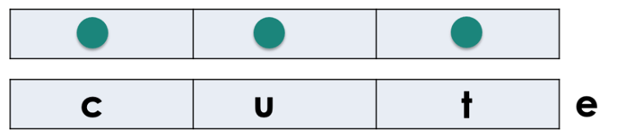
- Let’s say each sound in cute. /c/ /ū/ /t/

- X

ORTHOGRAPHIC MAPPING IRREGULAR HIGH FREQUENCY WORDS

High Frequency Words: Words that students see in print.
- The Dolch and Fry word lists are two often used lists of high frequency words.
- Many high frequency words follow typical sound-letter patterns.
- Some high frequency words have irregular spellings.

Sight Words: Words that a reader recognizes on sight.
- Most words become sight words in skilled readers.

Sample of High Frequency Words (Dolch)
after | again | an | any | as
ask | by | could | every | fly
from | give | going | had | has
her | him | his | how | just
know | let | live | may | of
old | once | open | over | put
round | some | stop | take | thank
them | then | think | walk | were
when

4 Step-Mapping Plan
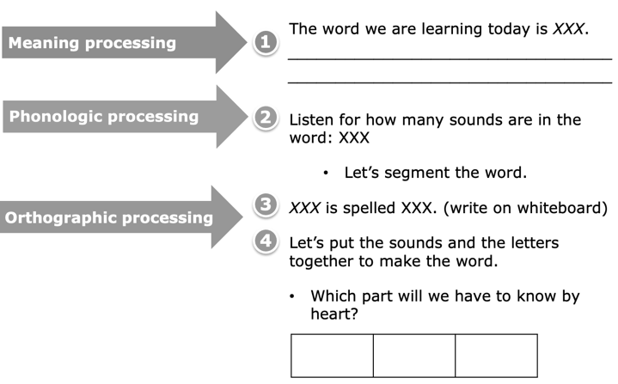

REFLECTION

Something New | Something Confirmed
I’ll Use It Soon | A Question

