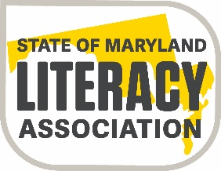

State of Maryland Literacy Association
Joseph J. Fox, Jr. Memorial Scholarship

Dear Guidance Counselor:
Several years ago our state reading association initiated a scholarship fund to encourage and support students who were interested in pursuing a teaching career. We are asking for your help in publicizing this scholarship opportunity.

As noted on the application information sheet, the Joseph Fox, Jr. Memorial Scholarship awards $2,000.00 to three Maryland high school recipients each year who plan to major in education and pursue some coursework in reading or reading-related fields.

Students interested in applying for this scholarship should go to www.somla.online and click on the scholarship committee tab for further information. To assist the applicant in completing all the necessary documentation, a verification form must be completed and requires a signature by an employee of the student’s school.

We hope that you will assist us in the endeavor. If you should need to contact me further regarding this scholarship information, please email me at: Ronnie Cantor
Cordially Yours,
Ronnie Cantor
Ronnie Cantor
Scholarship Chairperson
SoMLA

