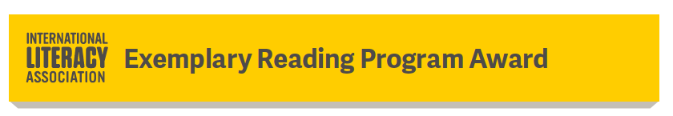

Hello SoMLA members and leaders,

We are pleased to announce the return of the Exemplary Reading Program Award. SoMLA is certain that we have several schools in Maryland that are eligible for this award. Please look over the information and think about the exemplary reading programs that exist in your school or in your county and apply.

Exemplary Reading Program Award
The Exemplary Reading Program Award recognizes outstanding reading and language arts programs at all grade levels (elementary, middle, and high school). Its purpose is to call the public's attention to outstanding programs in schools throughout Canada and the United States. Each participating state and provincial council, with an active ERPA committee chair, may choose one winning school a year.
All public, private, charter, and parochial schools in the United States and Canada are eligible for the award provided
- The state or province in which the school is located has an Exemplary Reading Program Award Committee currently in place to judge program applications from that state or province
- At least one faculty or staff member of that school is a current ILA member
Deadline: December 15, 2021
Application
For additional information, contact Sandy Keaton, skeaton1228@gmail.com.

