Donald Trump and K-12 Education: Five Things to Watch in 2017
By Alyson Klein on January 3, 2017 7:56 AM
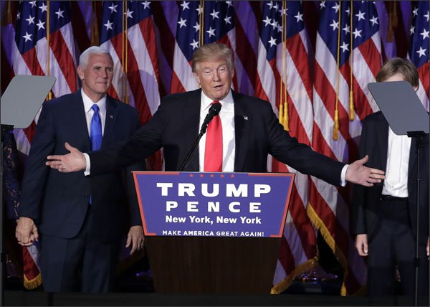
Happy New Year! It's officially time to start writing 2017 on your checks.
The presidential transition means an especially busy start to the year. President-elect Donald Trump may not have talked much about education on the campaign trail, but the first part of the year will tell us a lot about the direction he wants to go and how much of a priority he places on the issue. What's more, we'll get a glimpse of how well he's able to work with Congress on K-12, not to mention early and higher education.
Here are five things to watch in the months ahead:
Betsy DeVos' confirmation process
Trump's education secretary-designate and school choice advocate Betsy DeVos still needs to get the seal of approval from the U.S. Senate before she can start her new job. Ultimately, the GOP megadonor will probably get confirmed. She has donated to a number of Republicans on the Senate education committee, which will oversee her confirmation. Plus, she only needs a majority of the Republican-controlled Senate to sign off on her appointment.
But don't expect her confirmation hearing, which could be held on or around Jan. 11, to be smooth sailing. Democrats told the Washington Post that DeVos is one of four cabinet nominees they intend to oppose most vehemently. Expect scrutiny around the $5.3 million in unpaid fines and late fees that All Children Matter, DeVos' now-shuttered political action committee, owes Ohio. There will also likely be a close examination of her controversial record on school choice in Michigan, as well as opposition to her nomination in the civil rights community and among educators. And she could be asked about whether she has a plan to end the Common Core State Standards, something she's not legally able to do under the new Every Student Succeeds Act.
Education Department Staffing
DeVos may head up the U.S. Department of Education, but it will be just as important to see who ends up in other key positions, especially because the focus of DeVos' K-12 work has been so singularly on school choice. Picks like the deputy secretary, assistant secretary for elementary and secondary education, assistant secretary for planning evaluation and policy, and even chief of staff could matter a lot.
Look to see if DeVos—who, unlike most of her predecessors has never worked in a school district or at a college—brings in folks with hands-on experience. For now, Rob Goad, an aide to Rep. Luke Messer, R-Ind., who took leave to serve on the Trump campaign, is at the helm of the department's transition. And other folks, including some with ties to both former President George W. Bush and his brother, former Florida Gov. Jeb Bush, are also helping out with transition efforts.
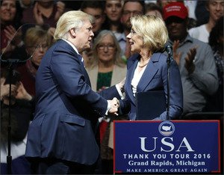
Every Student Succeeds Act Implementation
The Trump administration gets to make some early decisions that are important for implementation of ESSA. For instance, the new folks will get to decide whether to revise or simply toss some of the Obama administration's regulations for the law, including on accountability and a wonky spending issue called supplement-not-supplant. Both sets of regulations are on the hit list for Republican members of Congress.
The Obama administration set the first deadline for state ESSA plans as early April, but the Trump team could shift that. The new administration will also get to approve state plans and could use ESSA to further its school choice agenda.
First Big Policy Proposal
The only major K-12 policy Trump talked about on the campaign trail was school choice, and his selection of DeVos shows he's serious about pursuing the issue. But will his first big education policy proposal be the $20 billion voucher program he pitched on the campaign trail, or something more modest and easier to pass, like tax credits for K-12 education?
The timing of the proposal will also be important. Is education one of the first domestic policy areas to get attention, or does it take a back seat to issues that got more play during the campaign, like immigration and health care? And when education does come up, where will the new administration put its focus? Does Trump get started on K-12 right out of the gate, like Bush and President Barack Obama did, or does his administration tackle higher education, child care, or something else first? There are signs that child care may be ahead of K-12. Trump's daughter Ivanka, who is expected to play a key role in the administration, is reportedly already making calls to lawmakers on the issue.
Trump's First Budget Request
Trump's first budget proposal, which will cover federal fiscal year 2018, is likely to come out sometime in late winter or even spring. That will give us a sense of which Education Department programs the president wants to keep, shrink, or ditch. It will also provide key insight into how Trump and Company plan to deal with across-the-board cuts known as "sequestration" that are slated to be in place through the incoming president's first term.
President-elect Donald Trump gives his acceptance speech during his election night rally on Nov. 9 in New York. --John Locher/AP
President-elect Donald Trump shakes hands with his pick for Education Secretary, Betsy DeVos, during a rally in Grand Rapids, Mich., on Dec. 9. Paul Sancya/AP

