Conflicts of DeVos

Donald Trump, Betsy DeVos, and a Pay-to-Play Nomination
By Ulrich Boser, Marcella Bombardieri, and CJ Libassi Posted on January 12, 2017, 12:01 am
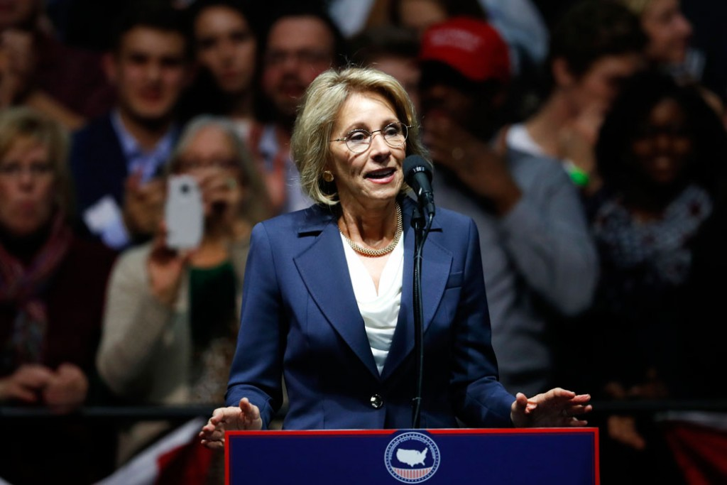
AP/Paul SancyaBetsy DeVos speaks during a rally in Grand Rapids, Michigan, on December 9, 2016.
Billionaire activist Betsy DeVos and her family have given a massive $4 million to the Republicans who will decide whether to confirm her as Trump’s secretary of education, according to a new analysis by the authors.
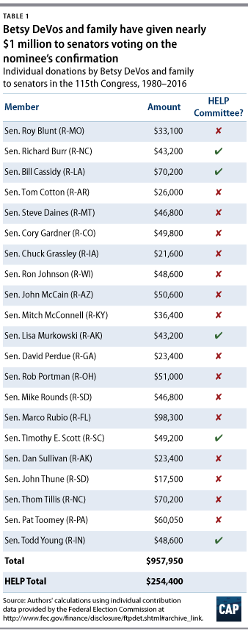
DeVos’ hearing begins this Wednesday, and her family has donated a quarter of a million dollars alone to the members of the education committee who are tasked with vetting her nomination. The DeVos family has given a total of more than $950,000 to 21 senators who will have the opportunity to vote on her confirmation.
On top of those direct contributions, DeVos and her family also gave $2.25 million last fall to the Senate Leadership Fund, a super PAC tied to Senate Majority Leader Mitch McConnell (R-KY). And the family has donated over $900,000 to the National Republican Senatorial Committee, a fundraising group for the Senate.
Altogether, that’s a $4 million bid to buy DeVos a cabinet position. While the donation tally goes back to 1980, the DeVoses gave 80 percent of it in the 2016 election cycle and 13 percent in the 2014 cycle. To uphold the ethical standards of the Senate—and avoid even the appearance of a conflict of interest—senators who have received donations from DeVos and her family should recuse themselves from considering her nomination.
Unfortunately, no member of the Senate has indicated that they might step aside. Put differently, Republicans under Trump are showing that they can be bought and sold.
For her part, DeVos, a long-time Republican megadonor, has made clear that her extensive campaign donations are meant to sway policymakers. “I have decided, however, to stop taking offense at the suggestion that we are buying influence,” DeVos once remarked. “Now I simply concede the point. They are right. We do expect something in return.”
It’s an approach she shares with her potential future boss, President-elect Donald Trump, who has also bragged about the political pull of his campaign donations. “I’ve given to everybody. Because that was my job,” Trump crowed at a rally last January. “I gotta give it to them. Because when I want something, I get it. When I call, they kiss my ass.”
For this analysis, the authors compiled campaign donations from DeVos and her relatives. The bulk of the $4 million comes from her and her husband, his siblings, their spouses, and his parents. Many of these relatives bundle their giving, making contributions on the same date and often in the same amount. Details are available here.
A number of media outlets and researchers have described the hundreds of millions of dollars the DeVos family has poured into right-wing causes for many years. A few have noted their pattern of giving to members of the Senate. But none have revealed a complete and up-to-date tally of her financial sway over the Senate that will consider her nomination.
DeVos has taken this pay-for-play approach before. Just consider the impact she had in her home state of Michigan last year. As a reward for passing a no-accountability charter school law in the state, the DeVos family once gave state Republicans $1.45 million in a seven-week period. That’s about an average of $25,000 a day. “A filthy, moneyed kiss” is how the Detroit Free Press’ editorial page editor described the lobbying effort.
If Michigan was a kiss of graft, though, Congress might soon be an orgy of corruption. DeVos will have her hearings in front of five members of the Senate Committee on Health, Education, Labor, and Pensions, or HELP, who have taken enormous checks from her and her relatives—interestingly, all in the last two election cycles.
It’s worth a closer look at the DeVos family donations to the HELP members. Sen. Tim Scott (R–SC) has received $49,200 from the DeVos family and was a keynote speaker at DeVos’ American Federation for Children annual summit in May 2016. Sen. Bill Cassidy (R-LA) has received at least $70,200 from the DeVoses. Two other HELP committee members, Sens. Richard Burr (R-NC) and Lisa Murkowski (R-AK), each have received $43,200 from the family. Newly elected Sen. Todd Young (R-IN), who has joined the HELP committee, got $48,600 from the DeVos family in 2016.
Unless these senators remove themselves from the nomination process, it appears that big money interests can simply purchase a seat at the Trump political table.
Some have tried to defend the donations. HELP committee chair Sen. Lamar Alexander (R-TN), for instance, downplayed the significance of DeVos’ giving pattern, telling Politico, “All of that is disclosed.”
“You can ask those senators and evaluate it yourself,” he said. “That’s the reason we have limits on campaign contributions and we have disclosures of those things.”
Not everything is so transparent, though. Indeed, Sen. Alexander himself received $4,500 from Alticor Political Action Committee, or ALTIPAC, in the last few years. This PAC belongs to Alticor, the DeVos family company and parent company of Amway—the multilevel marketing giant that fueled the DeVos family fortune—and receives nearly half of its funds from the DeVos family.
And, in addition to Sen. Alexander, nine other HELP members have received donations from ALTIPAC.
Unless Sen. Alexander and his colleagues do something to stop it, the coming administration is about to put a big “for sale” sign in front of Congress.

Methodology
Using Federal Election Commission, or FEC, data from 1980 through the present, we tallied the total direct contributions of Betsy DeVos and her family to members of the Senate in the 115th Congress as well as the Senate Leadership Fund and National Republican Senatorial Committee, both devoted to electing Republican senators. In addition, a handful of donations occurred too recently to be included in the bulk data released by the FEC. In those cases, we used Opensecrets.Org to update our data with the most recent information. In addition to Betsy DeVos, the following family members made donations that appear in the tally: Rensselaer Broekhuizen, Cassandra DeVos, Cheri Devos VanderWeide, Dalton DeVos, Dan DeVos, Douglas DeVos, Helen DeVos, Maria DeVos, Pamella DeVos, Richard DeVos Jr., Richard DeVos Sr., Suzanne DeVos, Sydney DeVos, and Elsa Prince-Broekhuizen.
Ulrich Boser is a Senior Fellow at Center for American Progress. Marcella Bombardieri is a Senior Policy Analyst at the Center. CJ Libassi is a Policy Analyst at the Center.

