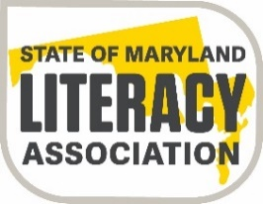

State of Maryland Literacy Association
Undergraduate Joseph J. Fox, Jr. Memorial Scholarship Application Form
2022-2023
Part One

Applicant: Please complete in full. Please type or print carefully.

Name: ________________________________________________________________
(last) (first) (middle)

Address: ___________________________________
___________________________________
Phone Number: ______________________________

Email Address: _______________________________

Date of Birth: ________________________________

High School Attending: ___________________________________________________

College or University you plan to attend: _____________________________________

Area of education you plan to pursue: _______________________________________

List the names of two people, other than relatives, whom you have asked to submit a letter of recommendation to the scholarship committee:

Name: __________________________________ Relationship: _________________________

Name: __________________________________ Relationship: _________________________

Please submit an essay explaining the reasons you are qualified and should receive this scholarship. Refer to the three-point rubric for guidance.

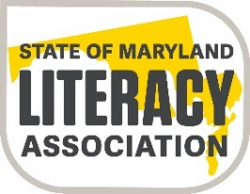

State of Maryland Literacy Association
Undergraduate Joseph J. Fox, Jr. Memorial Scholarship Application Form
2022-2023
Part Two
To be completed by a person from the school who is best qualified to evaluate the applicant (Principal, Counselor, or Teacher).
Name of student: _____________________________________________________________
(last) (first) (middle)

Name of high school: ____________________________________________________
Address of high school: ___________________________________
___________________________________
Phone number for high school: _____________________________
Student’s rank in graduating class: ________ in a senior class of __________students
Cumulative grade point average (at least a 3.2 on a 4.0 scale) GPA: _______________
PLEASE ENCLOSE A TRASNSCRIPT WITH THIS PART OF THE APPLICATION
Has the applicant submitted an application for admittance to an accredited college or university that will qualify him/her for teaching in the state of Maryland? ________________
Please rate the applicant to the best of your knowledge on the following information. Circle the most applicable description.
The applicant has demonstrated:
- an interest in teaching none slight moderate high
- community service in education-related activities none slight moderate high
- ability to do well in college none slight moderate high
Comments:______________________________________________________________________________________________________________________________________________________________________________________________________________________________________________________________________________________________________________
_________________________________ __________________________ _________________
(Signature) (Title) (Date)

State of Maryland Literacy Association
Undergraduate Joseph J. Fox, Jr. Memorial Scholarship Verification Form
2022-2023

Application Deadline: April 15, 2023
Application forms should be reviewed by the Principal, Counselor, or Teacher and this form completed by him/her and returned to the applicant.

 | Please check one
 | Forms Mailed Directly | Forms Returned to Applicant
Scholarship Application
Part One
Student Written Essay
Scholarship Application
Part Two
High School Transcript
Two Letters of Recommendation

_________________________________ __________________________ _________________
(Signature) (Title) (Date)

Application must be postmarked by April 15, 2023
Mail all parts of the application to:
Ronnie Cantor
Scholarship Committee Chairperson
2863 Dragon Fly Way
Odenton, MD 21113

