ESSA: Education Department Releases Guidance on Teachers
By Alyson Klein on September 27, 2016 10:20 AM
The U.S. Department of Education Tuesday released a blueprint to help states and districts make the most of out of more than $2 billion in federal money for teacher support, preparation, training, and more.
The new federal guidance also walks states and districts through changes to this pot of money—known as Title II—under the brand new Every Student Succeeds Act.The department recommends that states and districts use the funds to make sure that teachers are supported from the time they enter educator training programs, through their early years of teaching, and as they take on leadership positions, including the principalship.
And, the guidance reminds states and districts that they have to reach out to teachers, support personnel, community partners, and others when figuring out how to use their Title II funding.
"Educators play a critical role in securing our nation's economic future and preserving the promise of an excellent education for all children, especially those who have been historically underserved," said U.S. Secretary of John B. King, Jr., in a statement. "We don't just want educators to be part of the change; we need them to lead it."

Teachers and Equity
The guidance encourages states and districts to use Title II funds to make sure that all kids have access to an effective teacher, and to make sure teachers in high-needs schools get access to extra supports.
For instance, states and districts could use the money to:
- Give bonuses, pay raises, and other perks to attract excellent teachers to high-needs schools.
- Offer extra pay to teachers who teach in high needs subjects, or teach special populations, such as English-language learners.
- Create "co-teaching" classrooms in high-needs schools, where beginning teachers work alongside a more experienced educator.
- Address working conditions in high-needs schools, or give teachers who work in them extra time to plan and collaborate.
Many school districts use their Title II money to cut down on class size. That's allowable under ESSA, the department says, as long as there is evidence to back up the approach.

Educator Development
School districts across the country are trying to create so-called "career ladders" for teachers, and the department has some suggestions on how to use Title II money to make that happen. For instance, states and districts can:
- Use federal teacher quality funds to support preparation programs at traditional universities, but also for alternative-preparation programs, and teacher residency programs.
- Create or choose "academies" to prepare teachers, using funding under ESSA. (More on that below). States that want to go that route must first choose an "authorizer" that will supervise the academies and hold them accountable.
- Create mentorship programs for new teachers
- Hire or support "principal supervisors" to help school leaders in their work
- Train principals, including giving them time to learn from each other.

Teacher Evaluation
States and districts can also use their money to create teacher-evaluation systems, but perhaps just as important, they don't have to do that. Teacher evaluations based on student outcomes were a huge priority for the Obama administration during its first six or so years in office. It championed the policy through Race to the Top and No Child Left Behind waivers. Under ESSA, states don't have to create teacher-evaluation systems that rely in part on student test scores, but they can if they want, or they can use their federal teacher quality money to craft other types of evaluation systems.
The department recommends creating evaluation systems that take into account multiple measures, including student academic growth, but also observations, and parent/student surveys. Evaluations should also be valid and reliable, and teachers should be clear on what they are being measured on, and get to see their entire evaluation, not just the overall rating.

Funding Changes
There are some changes to the way Title II money flows under ESSA. For instance, states can now reserve up to 2 percent of their total Title II funding at the state level to help prepare teachers and principals to work in high-needs schools. And they can reserve up to 3 percent of districts' allocation for principal support. This chart, included with the guidance, illustrates the breakdown of the funding.
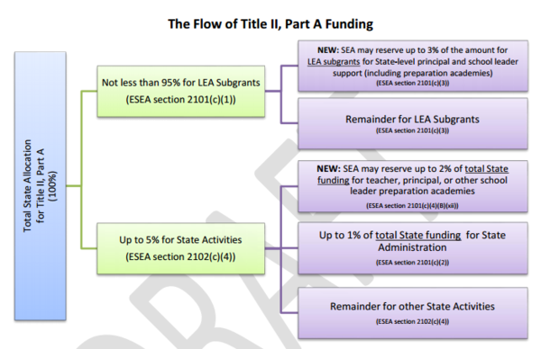
Importantly, states and districts may not have as much Title II money to play around with during the 2017-18 school year, the first year of ESSA implementation, as they do right now. The program is currently getting about $2.3 billion, but spending bills pending in the House and Senate seek to cut it down, from just over $2 billion to $1.9 billion, respectively.
Of course, Title II isn't the only pot of federal money for teacher quality. In fact, the department doled out $5.1 in Teacher Quality Partnership grants to teacher-preparation programs that use a "residency model"—where prospective teachers take courses but also teach alongside a veteran educator—and other programs with a strong, "hands-on" focus.

