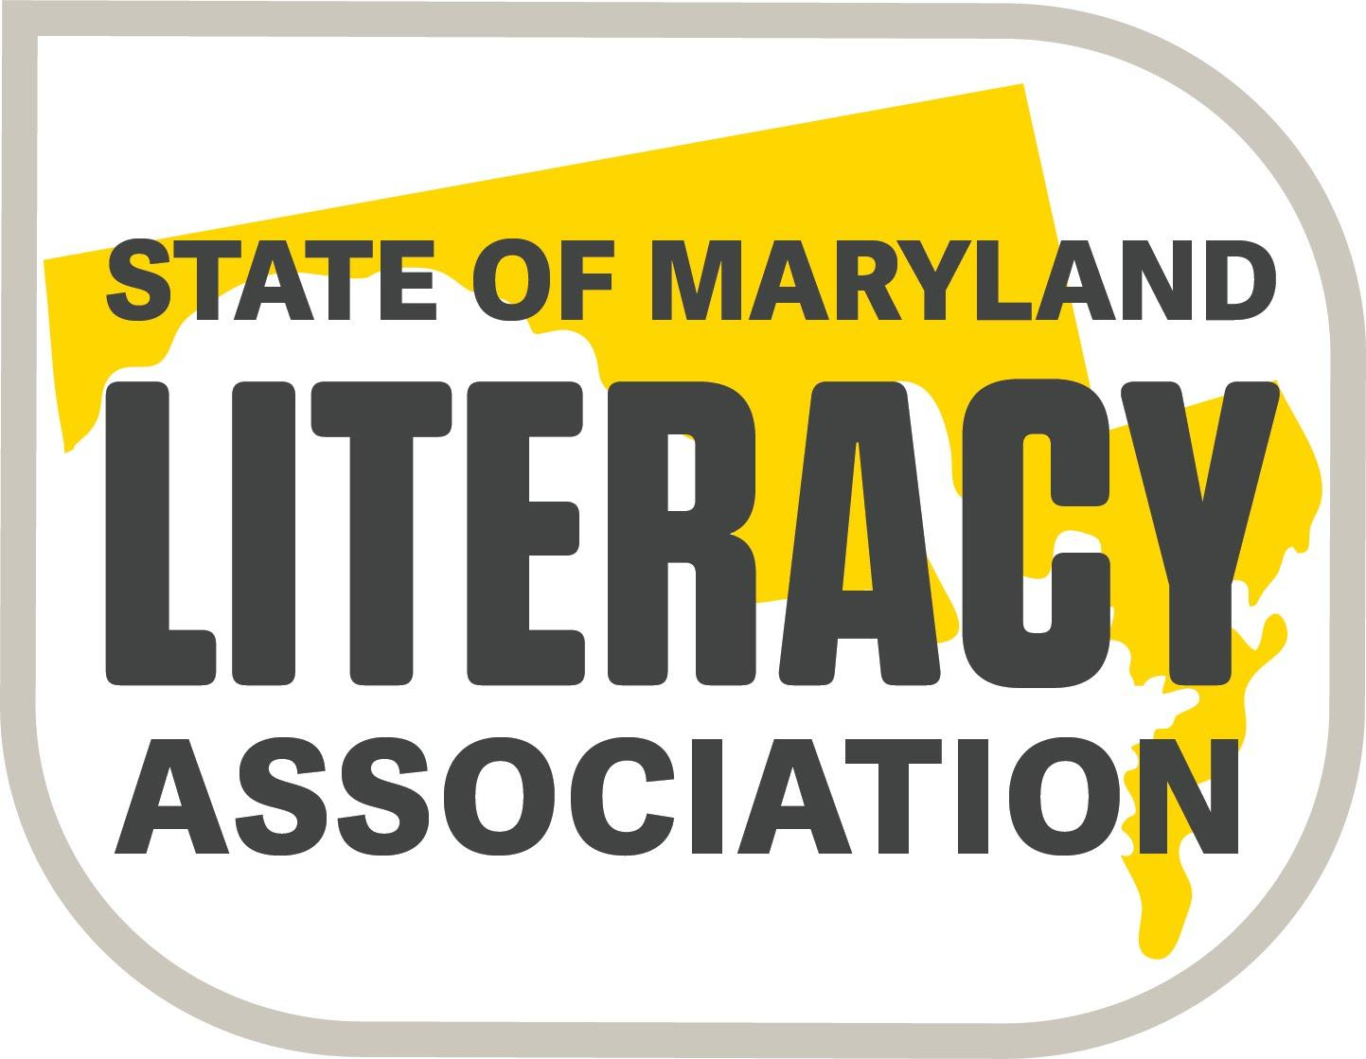  (Formerly SoMIRAC) | Exhibitor Registration  48th Conference  SoMLA (Formerly SoMIRAC)  April 1-3, 2020  Delta Hotel by Marriott  (Hunt Valley Inn)  245 Shawan Road  Hunt Valley, MD 21031  410-785-7000 | April 1-3, 2020
Date _________________
Company Name: ________________________________
Address: _______________________________________
Contact for Vendor Application: _________________________________
Phone: ______ FAX: ______Email: ________________________________
Item | Number | Total
6 ft. Table ($500 per table) |  | $
3 ft. Additional Space ($200) (*no table) |  | $
Square Hi-top table ($200) |  | $
Electrical Outlet ($40) |  | $
Conference Program Business Card sized Patron Ad ($50) (Black & White only) |  | $
Additional lunches to purchase - (1 lunch per table is included in the table cost.) |  | $
Vendor Sessions-See page 4 | (More info to follow) | (To be billed)
Totals |  | $

The following persons will represent the company at the exhibit booth:
(Please print all names attending with your company for badges to be prepared)

Please list the following information as you would like it to appear in the conference program. Please print clearly.
Company Name *(Required)
Sales representative’s name: *
Sales representative’s email address *
Sales representative’s phone number*

One Box lunch per day is included in the cost of each table. Calculate lunch choices by the number of tables for which you are paying . Indicate the choices for those free lunches as well as any additional lunches you wish to purchase for other associates at your table.

This year a buffet lunch is available in Salons E/F daily. Only pay for the additional lunches requested.
 |  | # Free | # Paid
Wednesday Lunch (Box lunch or buffet)  ** 1 lunch is included per table-additional lunches can be ordered @ $18 per lunch. Indicate the number of each. | ____Veggie Wrap  ____Tuna Sandwich  ____Turkey Sandwich  ____Garden Salad w/grilled chicken  ____ Salon E/F buffet lunch
Thursday Lunch (Box lunch or buffet)  ** 1 lunch is included per table-additional lunches can be ordered @ $18 per lunch. Indicate the number of each. | ____Veggie Wrap  ____Tuna Sandwich  ____Turkey Sandwich  ____Garden Salad w/grilled chicken  ____ Salon E/F buffet lunch
Friday Lunch (Box lunch or buffet)  ** 1 lunch is included per table-additional lunches can be ordered @ $18 per lunch. Indicate the number of each. | ____Veggie Wrap  ____Tuna Sandwich  ____Turkey Sandwich  ____Garden Salad w/grilled chicken  ____ Salon E/F buffet lunch
*Non-Profit Partner Organizations must purchase lunches for each day. | Total Paid-  (Place on front page of form) | No Cost | $

**Lunches cannot be ordered at the conference. They must be ordered in advance.

General 2019 Exhibitor Information

- EXHIBIT HOURS: April 1-3, 2020– 8:00 am - 4:00 pm. Keep in mind that some attendees are only at the conference on Friday. Please keep your booth open until the last session of the day begins on Friday (1:45 PM) to accommodate these attendees. Thank you!

- HOTEL RESERVATIONS: Make your own reservations directly by contacting the Delta Hunt Valley Inn between 8 am and 5 pm at 410-785-7000. A limited number of rooms are available at the conference rate so early reservations are strongly recommended. Identify yourself as a member of SoMLA to receive the conference rate.

- SET-UP: Exhibitors may set-up on Tuesday, March 31st AFTER 4:00 p.m.
Please check in at the SoMLA registration desk at the foot of the escalator for exhibitor materials on Tuesday evening. Donations for the Literacy Lottery may be delivered to the downstairs Registration desk on Tuesday evening, or any time on Wednesday. Someone from SoMLA will also be collecting items prior to Thursday morning’s display.

- SHIPPING MATERIALS: If you need any boxes shipped for your set-up, please mail them to the Hunt Valley Inn clearly marked to the attention of SoMLA. These boxes should arrive no earlier than Friday, March 27th (3 business days prior to the conference). Be sure your company’s name and representative’s name are CLEARLY written on all of the boxes so that they can be delivered to your table. If the boxes are received prior to 3 days before the conference, you will incur a holding charge from the hotel. In addition, the hotel will also charge you if their employees have to move/deliver more than 10 boxes.

- Example: Your Company Name (AND Representative)
C/O SoMLA (or State of Maryland Literacy Association Conference)
Delta Hotel-Hunt Valley
245 Shawan Road
Hunt Valley, MD 21031 – 1099

- The exhibitor company agrees to donate merchandise for the Scholarship Fund Drive (Literacy Lotto). This merchandise is auctioned off at the conference for conference attendees. Please drop off your donation at the registration desk when you arrive at the hotel clearly marked with your company name. Some suggestions are gift cards, company gift certificates, programs or kits, books, wine, etc.

- Please email your completed registration form to Mary Lou Nelson at somla.exhibitor@gmail.com to reserve your tables and then send along your check or you can mail your completed registration form and check to Mary Lou Nelson, 108 Dove Lane, Centreville, MD 21617. Please make checks payable to SoMLA or State of Maryland Literacy Association.

- The registration fee is not refundable if tables are canceled less than 30 days before the conference.

- The vendor registration form may also be found on our website at www.somla.online under the Conference tab, then choose Annual Conference link.

- Business card size ads are available to be in the program. Please include a print-ready card no larger than a standard business card. All printing in the conference program will be in black and white only. Ads will cost $50.00 per business card entry. There may be up to 10 cards per page located at the back of the program.

SoMLA will make available Exhibitor Sessions for the participants during the SoMLA Conference to be held April 1-3, 2020. The expectation is that the sessions will provide high-quality professional development and allow the registered exhibitors to showcase their product or service. For audience members, examples of professional development would include an introduction to a teaching strategy, learning about research, or a hands-on exercise.

Sessions of this type will be held in various locations and time frames indicated to be announced once all sessions have been placed and will be available to vendors on a first-come, first served basis. Please check back in late January for availability of these sessions and spaces.

For additional information contact: Mary Lou Nelson at somla.exhibitor@gmail.com (*Please note new email)
Call (Home) 410-758-2378 or (Cell) 410-490-2096. (There is NO Fax number)

Because of the association name change from SoMIRAC to SoMLA, a new 990 form was attached last year, but is available upon request. It is documentation of our non-profit status.

We look forward to another great conference and appreciate your participation. Please let me know if you have any questions.
(Home) 410-758-2378
(Cell) 410-490-2096
somla.exhibitor@gmail.com
Mary Lou Nelson
SoMLA Exhibitor Contact
108 Dove Lane, Centreville, MD 21617

