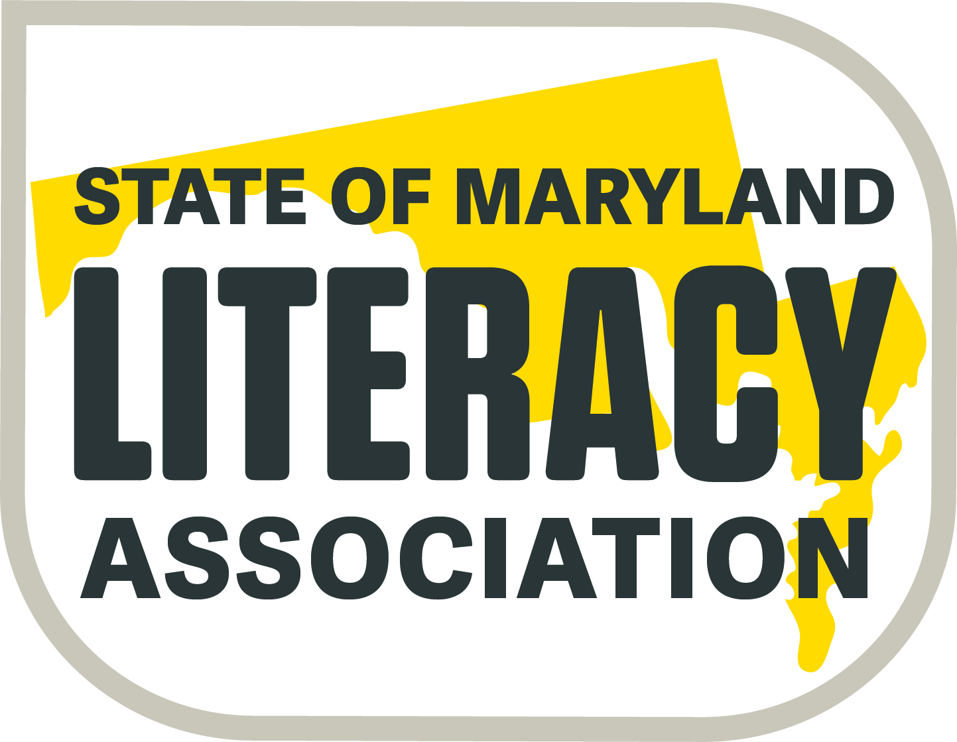  (Formerly SoMIRAC) | Exhibitor Registration  47th Conference  SoMLA (Formerly SoMIRAC)  April 3-5, 2019  Delta Hotel by Marriott  (Hunt Valley Inn)  245 Shawan Road  Hunt Valley, MD 21031  410-785-7000 | Filling Our Cups  with Literacy
Date _________________
Company Name: ________________________________
Address: _______________________________________
Contact for Vendor Application: _________________________________
Phone: ______ FAX: ______Email: ________________________________
Item | Number | Total
6 ft. Table ($500 per table) |  | $
3 ft. Additional Space ($200) (*no table) |  | $
Square Hi-top table ($200) |  | $
Electrical Outlet ($40) |  | $
Conference Program Business Card sized Patron Ad ($50) (Black & White only) |  | $
Additional lunches to purchase - (1 lunch per table is included in the table cost.) |  | $
Vendor Sessions-See pages 3-4 | Complete page 4 if interested | (To be billed)
Totals |  | $

The following persons will represent the company at the exhibit booth:
(Please print all names for badges to be prepared)

Please list the following information as you would like it to appear in the conference program. Please print clearly. *(Required)
Company Name *(Required)
Sales representative’s name: *
Sales representative’s email address *
Sales representative’s phone number: *

One Box lunch per day is included in the cost of each table. Calculate lunch choices by the number of tables you are renting. Indicate the choices for the free lunches as well as any additional lunches you wish to purchase.

This year a buffet lunch is available in Salons E/F daily. Only pay for the additional lunches requested.
 |  | # Free | # Paid
Wednesday Lunch (Box lunch or buffet)  ** 1 lunch is included per table-additional lunches can be ordered @ $17 per lunch. Indicate the number of each. | ____Veggie Wrap  ____Tuna Sandwich  ____Turkey Sandwich  ____Garden Salad w/grilled chicken  ____ Salon E/F buffet lunch
Thursday Lunch (Box lunch or buffet)  ** 1 lunch is included per table-additional lunches can be ordered @ $17 per lunch. Indicate the number of each. | ____Veggie Wrap  ____Tuna Sandwich  ____Turkey Sandwich  ____Garden Salad w/grilled chicken  ____ Salon E/F buffet lunch
Friday Lunch (Box lunch or buffet)  ** 1 lunch is included per table-additional lunches can be ordered @ $17 per lunch. Indicate the number of each. | ____Veggie Wrap  ____Tuna Sandwich  ____Turkey Sandwich  ____Garden Salad w/grilled chicken  ____ Salon E/F buffet lunch
*Non-Profit Partner Organizations must purchase lunches for each day. | Total Paid-  (Place on the front page of form) | No Cost | $

**Lunches cannot be ordered at the conference. They must be ordered in advance.

Again this year-If you would like to include a business card size ad in the program this year in addition to your company name and contact information being listed in the program, please include a print-ready card no larger than a standard business card. All printing in the conference program will be in black and white only. These ads will cost $50.00 per business card entry. There will be up to 10 cards per page located at the back of the program. Print ready copy must be received by March 1st to insure inclusion in the program.

- The exhibitor company agrees to donate merchandise for the Scholarship Fund Drive (Literacy Lotto). This merchandise is auctioned off at the conference for conference attendees. Please drop off your donation at the registration desk when you arrive at the hotel clearly marked with your company name. Some suggestions are gift certificates for products, or general gift cards, programs or kits, books, etc.

- You can email your completed registration form to Mary Lou Nelson at somirac.vendors@gmail.com to reserve your tables and then send along your check or you can mail your completed registration form and check to Mary Lou Nelson, 108 Dove Lane, Centreville, MD 21617. Please make checks payable to SoMLA or State of Maryland Literacy Association.

- The registration fee is not refundable if tables are canceled less than 30 days before the conference.

- The vendor registration form may also be found on our website at www.somla.online under the Conference tab, then choose Annual Conference link.

- Because of the association name change from SoMIRAC to SoMLA, a new W-9 form will be attached to this document. Please forward it to your finance office or the appropriate person that would need documentation of our non-profit status.

Once again, SoMLA will make available Exhibitor Sessions for the participants during the SoMLA Conference to be held April 3-5, 2019. The expectation is that the sessions will provide high-quality professional development and allow the registered exhibitor to showcase their product or service. For audience members, examples of professional development would include an introduction to a teaching strategy, learning about research, or a hands-on exercise.

Sessions of this type will be held in locations and time frames indicated on the application and will be available to vendors on a first-come, first served basis. Please indicate your 1st, 2nd, and 3rd choices on the application.
Confirmation of reservations will arrive in a return e-mail, and payment will then be due by February 15, 2019. All vendor sessions will be included in the conference program, and exhibitors will be welcome to publicize their presentation(s) at their tables as well.
If you are interested in an exhibitor session, please complete the attached application and return it promptly.

For additional information contact: Mary Lou Nelson at somirac.vendors@gmail.com
Call (Home) 410-758-2378 or (Cell) 410-490-2096. (There is NO Fax number)

To: Conference Exhibitors
Re: General 2019 Exhibitor Information

EXHIBIT HOURS: April 3-5, 2019 – 8:00 am - 4:00 pm. Keep in mind that some attendees are only at the conference on Friday. Please keep your booth open until the last session of the day begins on Friday (1:45 PM) to accommodate these attendees. Thank you!

HOTEL RESERVATIONS: Make your own reservations directly by contacting the Delta Hunt Valley Inn between 8 am and 5 pm at 410-785-7000. A limited number of rooms is available at the conference rate so early reservations are strongly recommended. Identify yourself as a member of SoMLA to receive the conference rate.

SET-UP: Exhibitors may set-up on Tuesday, April 2nd AFTER 4:00 p.m.
Please check in at the SoMLA registration desk at the foot of the escalator for exhibitor materials on Tuesday evening. Donations for the Literacy Lottery may be delivered to the downstairs Registration desk on Tuesday evening, or any time on Wednesday. Someone from SoMLA will also be collecting items prior to Thursday morning’s display.

SHIPPING MATERIALS: If you need any boxes shipped for your set-up, please mail them to the Hunt Valley Inn clearly marked to the attention of SoMLA. These boxes should arrive no earlier than Friday, March 29th (3 business days prior to the conference). Be sure your company’s name and representative’s name are CLEARLY written on all of the boxes so that they can be delivered to your table. If the boxes are received prior to 3 days before the conference, you will incur a holding charge from the hotel. In addition, the hotel will also charge you if their employees have to move/deliver more than 10 boxes.

Example: Your Company Name (AND Representative)
C/O SoMLA
Delta Hotel-Hunt Valley
245 Shawan Road
Hunt Valley, MD 21031 – 1099

We look forward to another great conference and appreciate your participation. Please let me know if you have any questions.
(Home) 410-758-2378
(Cell) 410-490-2096
somirac.vendors@gmail.com
Mary Lou Nelson
SoMLA Exhibitor Contact
108 Dove Lane, Centreville, MD 21617

Rooms Available  Costs & Capacity Seating | Cost per session | Wednesday,  April 11, 2018 | Thursday,  April 12, 2018 | Friday,  April 13, 2018
Pimlico (30 people) | $150.00 | 8:15-9:15 | 8:15-9:15 | 8:15-9:15
Pimlico (30 people) | $150.00 | 10:45-11:45 | 10:45-11:45 | 10:45-11:45
Pimlico (30 people) | $150.00 | 12:30-1:30 | 12:30-1:30 | 12:30-1:30
Pimlico (30 people) | $150.00 | 1:45-2:45 | 1:45-2:45 | Not available
Maryland 3 (110 people) | $250.00 | 12:30-1:30 | Not available | Not available
Maryland 3 (110 People) | $250.00 | 1:45-2:45 | Not available | Not available

Exhibitor Sessions Application: Please copy this page and indicate your 1st, 2nd and 3rd choices for day and time. Please note if you want multiple days or times to be considered.

1st Day/time___________________ 2nd Day/time___________________ 3rd Day/time___________________ choices.
- Please do not purchase box lunches for audience members. Soft drinks or dessert for participants may instead be provided.
- Complete this information for inclusion in the conference program:
Title of Session -
Brief description of the session for the conference program:
Name of Speaker:
Company Sponsor:
Sales Representative’s Name: | ```
Sales Representative’s Email Address:
Sales Representative’s Phone Number:

Complete this application and email it to Mary Lou Nelson at somirac.vendors@gmail.com
These rooms and sessions are on a first come, first reserved basis.

